Fort Nelson Minor Hockey Association
Executive Meeting Minutes
August 12, 2020 Woodlands Hotel

In Attendance Absent

Ryan Carter Nicole Ashdown Weylin Ashdown
Shastine Fischer Shawna Wark Lisa Rowley
Jason Kay Heather Robinson Holly Leroux
Sonny Olkh Brenda Enax Kai Potter
Sean O’Shaughnessy
Heather Eling

Minutes recorded by Heather Eling

1. 7:00 PM Meeting called to order by Ryan Carter. Not enough attendees for quorum so meeting will be considered informal for information purposes only.

2. Request for any last minute additions – none from table.

3. Business Arising from Minutes

- Shastine now has the rest of the plaques and the Bryan Bell award is still to be presented to the recipient

- Further discussion on record keeping issues from last meeting. Ryan will be making a formal request for all paper and electronic records from the past treasurer. If we do not receive these promptly then a Letter of Demand will be sent to the past treasurer to limit FNMHA liability.

- Shastine and Shawna are still working to consolidate our many bank accounts into one single account. They are investigating which bank can best provide the service we will need.

4. Executive Reports

President - Ryan Carter:

- Nothing to add at this time.

Vice President - Shastine Fischer:

- Needs to get together with Ryan for one day to go through the FNMHA Policy and Procedure. They will work out a suitable time.

Treasurer – Shawna Wark: (absent)

Secretary – Heather Eling:

- Nothing to add at this time.

Head Coach – Weylin Ashdown: (absent)

Head Referee - Kai Potter : (absent)

Risk Manager - Sonny Olkh :

- Nothing to add at this time.

Registrar - Heather Robinson : (absent)

Publicity - Jason Kay :

- Need jerseys sizes and quantities to create the order. Sean will ask Linda for historical ordering and stock tracking.

- Looking to have 25 player jerseys per team + 2 goalie jerseys. Discussed whether to do straight numbering (eg. 1-25 (no #13)), or skip some of the less popular numbers and include some celebrity hockey player numbers (eg. Sydney Crosby, Connor McDavid…). Sean and Jason to work together on order.

- Jason was concerned the jersey designs may be too similar for FN vs FN games. Table not too concerned on this but perhaps need an opinion from Kai.

- For reference here are the designs chosen for the new jerseys:
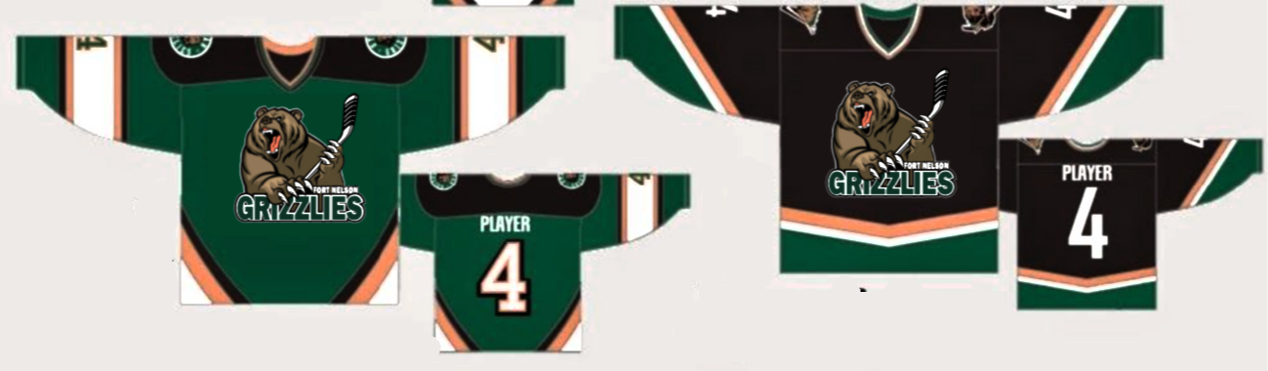

- Up for consideration is FNMHA purchasing jersey socks to match the new jersey design and having them available fro purchase by parents who wish to buy them.

Ice Coordinator - Lisa Rowley : (absent)

Gaming Coordinator - Holly Leroux : (absent)

Fundraiser - VACANT :

Equipment Manager – Sean O’Shaughnessy :

- Will be working with Jason on jersey purchasing.

- Need to organise puck sponsorship for the coming season. Ryan suggested that we have the logo and sponsor info on one side of the puck only and have it printed in a better quality than last year.

- Also need all sponsors from last year followed up with, and sponsors for the new year secured. Team photo plaques saying thank you to sponsors should be organised. Discussion of possible candidates for fundraising/sponsorship roles.

5. Division Coordinator Reports

Under 7 - VACANT :

Under 9 - Nicole Ashdown : (absent)

Under 11 - VACANT :

Under 13 - VACANT:

Under 15 - VACANT:

Under 18 - Brenda Enax: (absent)

Girls - VACANT:

6. New Business

Return to Play Update

Sonny presented a rough draft of the FNMHA Return to Play. Lots of good work done already! Ryan, Sean and Sonny need to meet with Harvey from the Rec Centre to work out what off ice facilities the players will have access to (benches, change rooms, washrooms etc.), as well as questions of whether we will have both ice surfaces and can we secure more time if Mile 300 is not using as much this year and when can we expect a date for when ice will be in and available. Consulting schedules, they will try to arrange a meeting with him the week of August 24-27.

Most of the on ice component has been completed within the provincial guidelines but some guidelines require clarification before the rest of the on ice plan can be completed. (numbers of players on/off ice; does having the wall up count as 2 ice surfaces and allow that number to be on each side etc).

Shastine would like this all set up and online by September so we can work toward registration. On this topic we also need to decide if we keep fees at the current rate and have the association eat any additional costs of needing more ice time for more teams if they need to be small teams.

We are all fielding enquiries regarding when registration and hockey may begin so Jason to create a facebook post along the lines of “The FNMHA Executive is currently working on our Return to Play plan. We are having meetings with the Rec Centre management to ensure we are working on the same safe guidelines for players and parents both on ice and off. We are also closely following all the provincial regulations and guidelines to ensure coaches, players and referees are safe on the ice this season. We thank you for your patience and look forward to letting you know more once our plan is complete.”

Team Snap Update

Shastine and Heather R have to share the admin login for the Team Snap website so only one can be working on the site at a time. They are making progress though and Heather is currently working on building the registration side. Shastine has not found a place to keep the minutes on the new site so will send a ticket to Team Snap to solve this.
Shastine also needs to decommission our old site.

Jersey Update

As detailed above in Jason and Sean’s reports.

Next Meeting September 2nd, Location TBA. Meeting Adjourned 8:04 pm

