Fort Nelson Minor Hockey Association
AGM Minutes
May 20, 2020

Call to Order

Meeting Location: Meeting conducted online over Zoom platform due to Social Distancing requirements.

Meeting Chair: Ryan Carter

Minutes Recorded by: Heather Eling

Executive Members In Attendance Executive Members Absent

Ryan Carter Lisa Rowley Holly Leroux
Shastine Fischer Heather Robinson Nicole Ashdown
Katina Vatcher Brenda Enax Linda Brenton
Heather Eling Jason Kay Ryan Kerr
Janelle Badine Jennifer Thomas Kai Potter
Weylin Ashdown Sonny Olkh
Shawna Wark

FNMHA General Members In Attendance

Meredith Power

___________________________________________________________________________________________

1. 7:00 PM Meeting called to order by Ryan Carter

Quick overview of how Covd-19 Social Distancing requirements meant the cancellation of our scheduled April 29, 2020 AGM. Executive met over ZOOM on May 6, 2020 to discuss how to complete an AGM and elect a new executive fairly and openly. The decision was made to contact all membership via coordinators to request nominations for executive positions beginning May 7, 2020. Members were given 7 days to make nominations with this closing May 14, 2020. There was an additional 6 days available before the ZOOM AGM in which voting could occur if required. There were no positions with more than one nomination so voting was not required. ZOOM AGM Meeting invites were sent out to all FNMHA members via coordinators so they all had the option to join the AGM meeting if they so desired.

2. Reading and Acceptance of previous minutes from 2019 AGM

2019 AGM Minutes were read by Ryan Carter.

Motion to accept minutes: Heather Eling Second: Sonny Olkh All in Favour

3. Treasurers Report including yearend financial statements

Katina Vatcher presented the Treasurers Report and financial statements for the 2019-2020 season.
She also took time to thank the FNMHA association for all the kindness she has received over the last 13 years in the position. She is stepping down as treasurer.
Ryan Carter thanked her for her many years of service and asserted that a formal thank you would be organised next time we can get together for awards.

<< FINANCIAL STATEMENTS INSERTED HERE>>
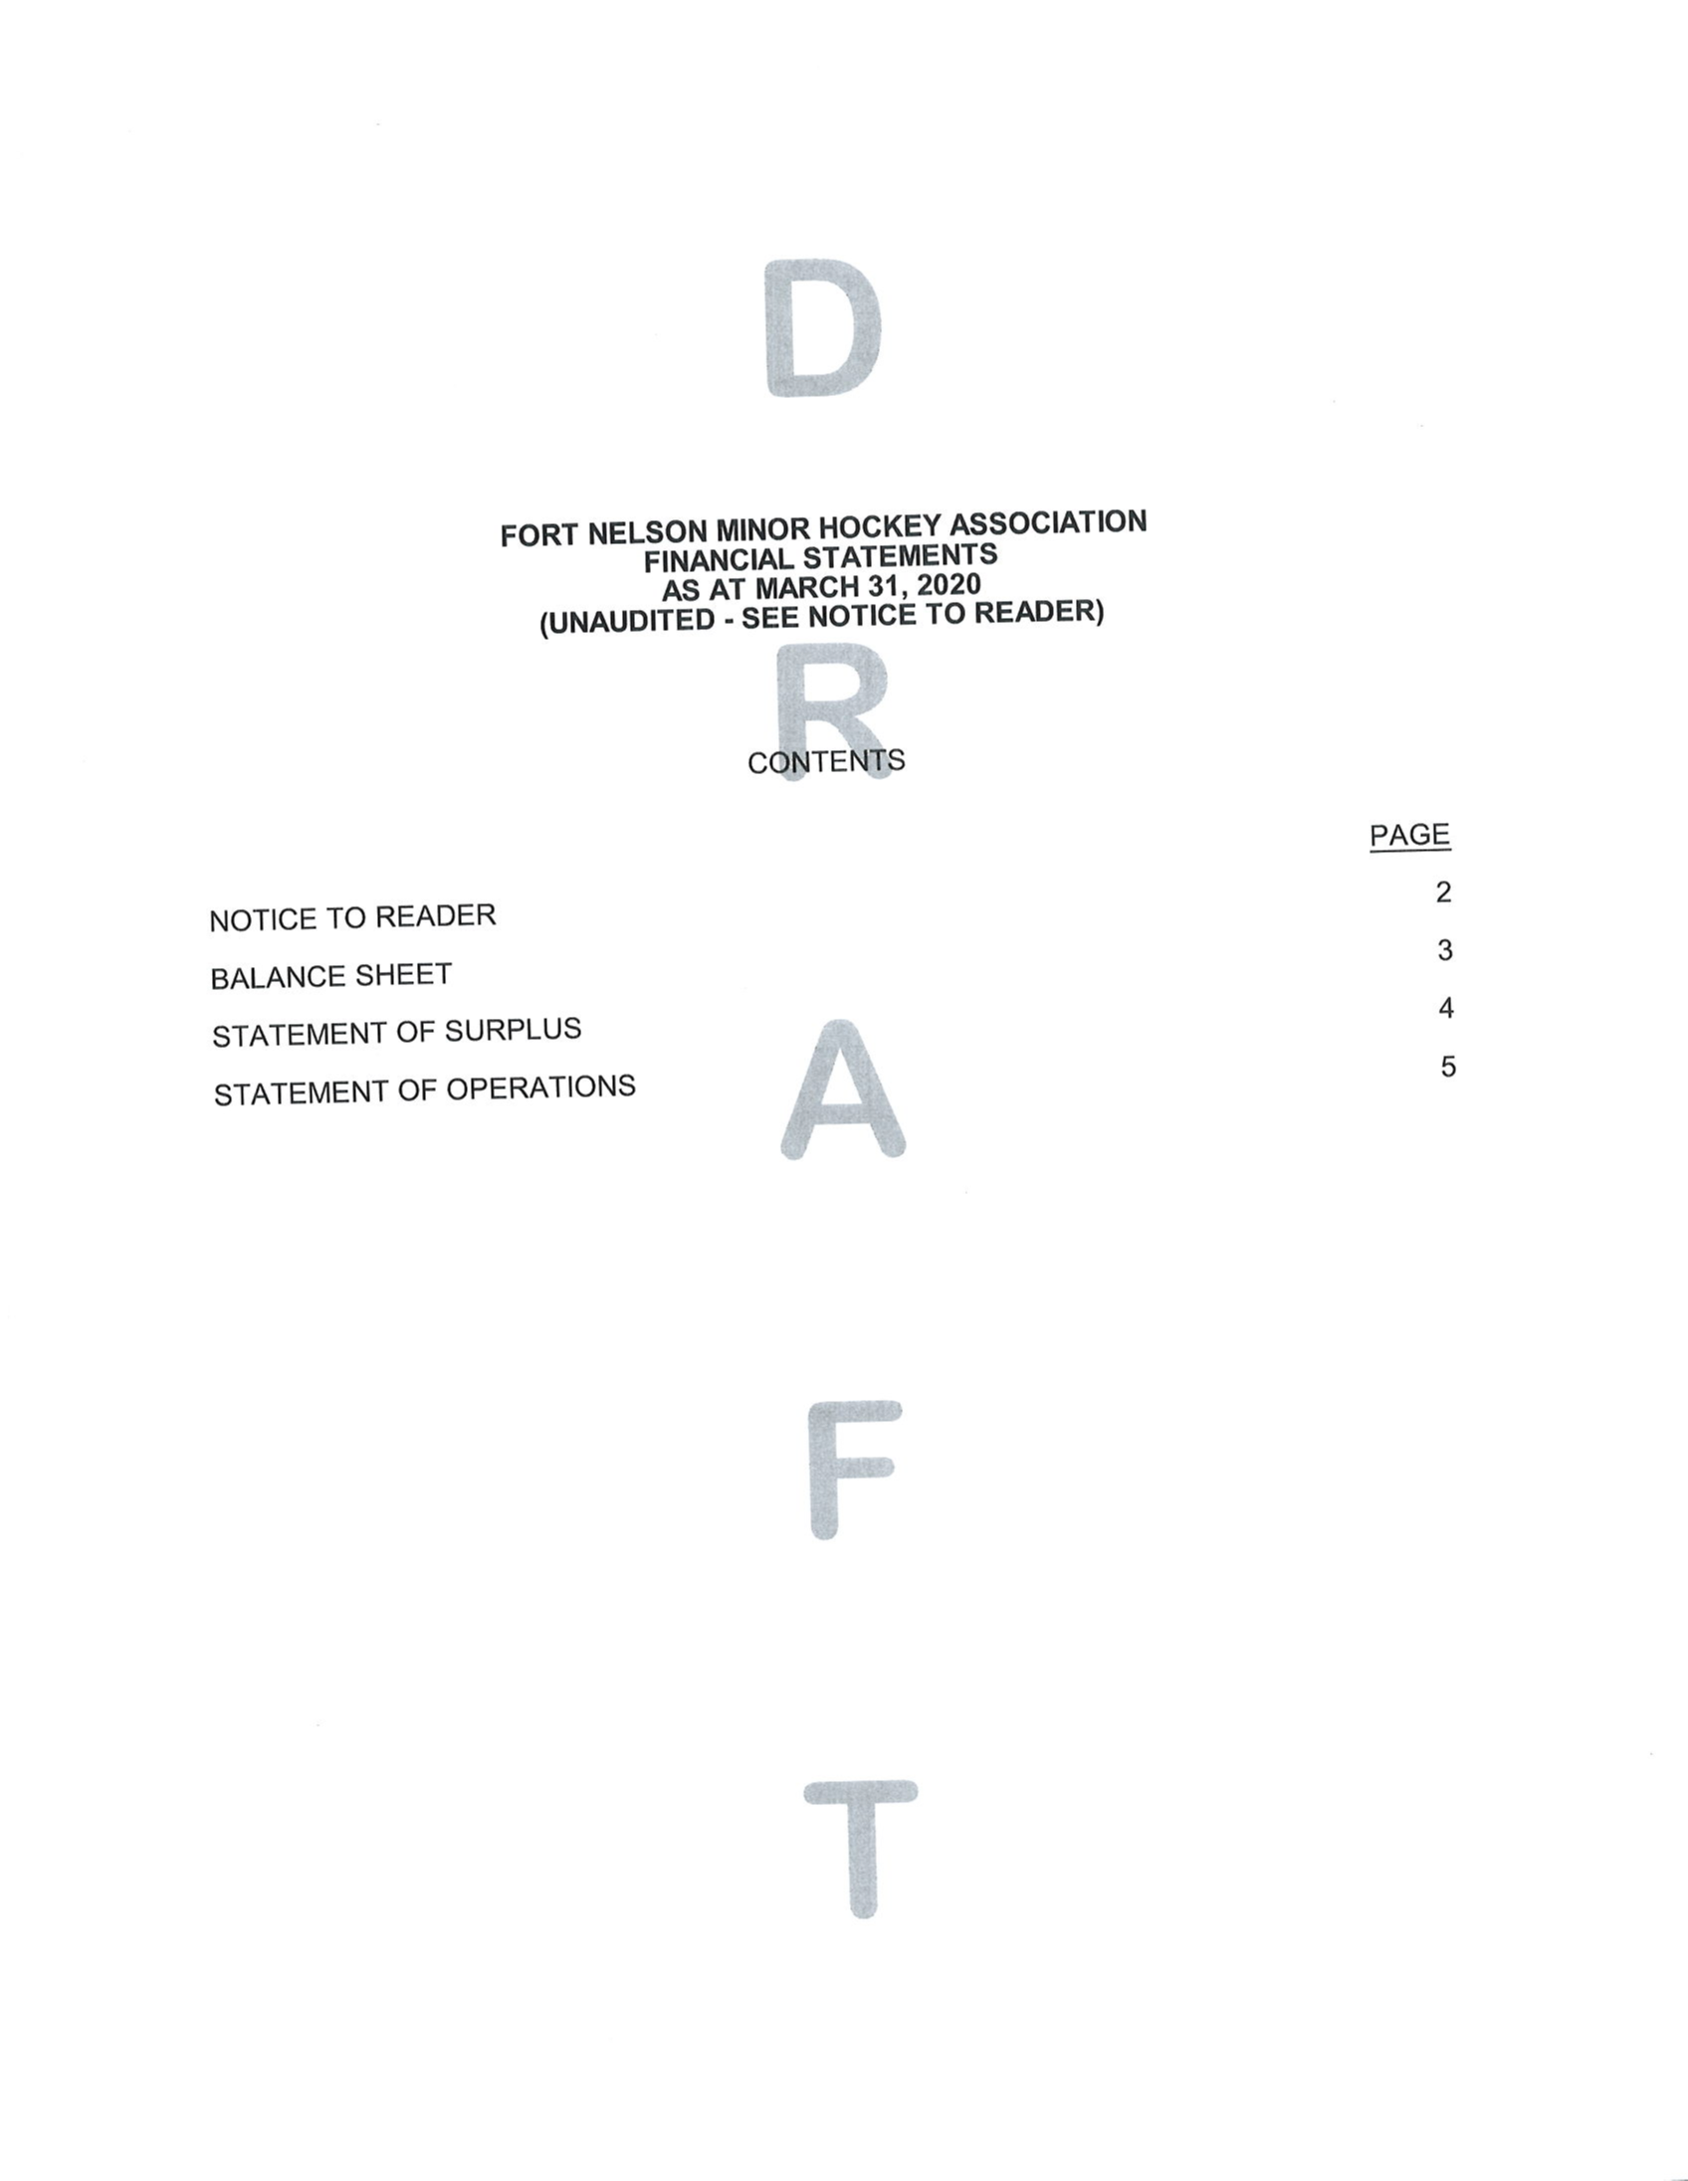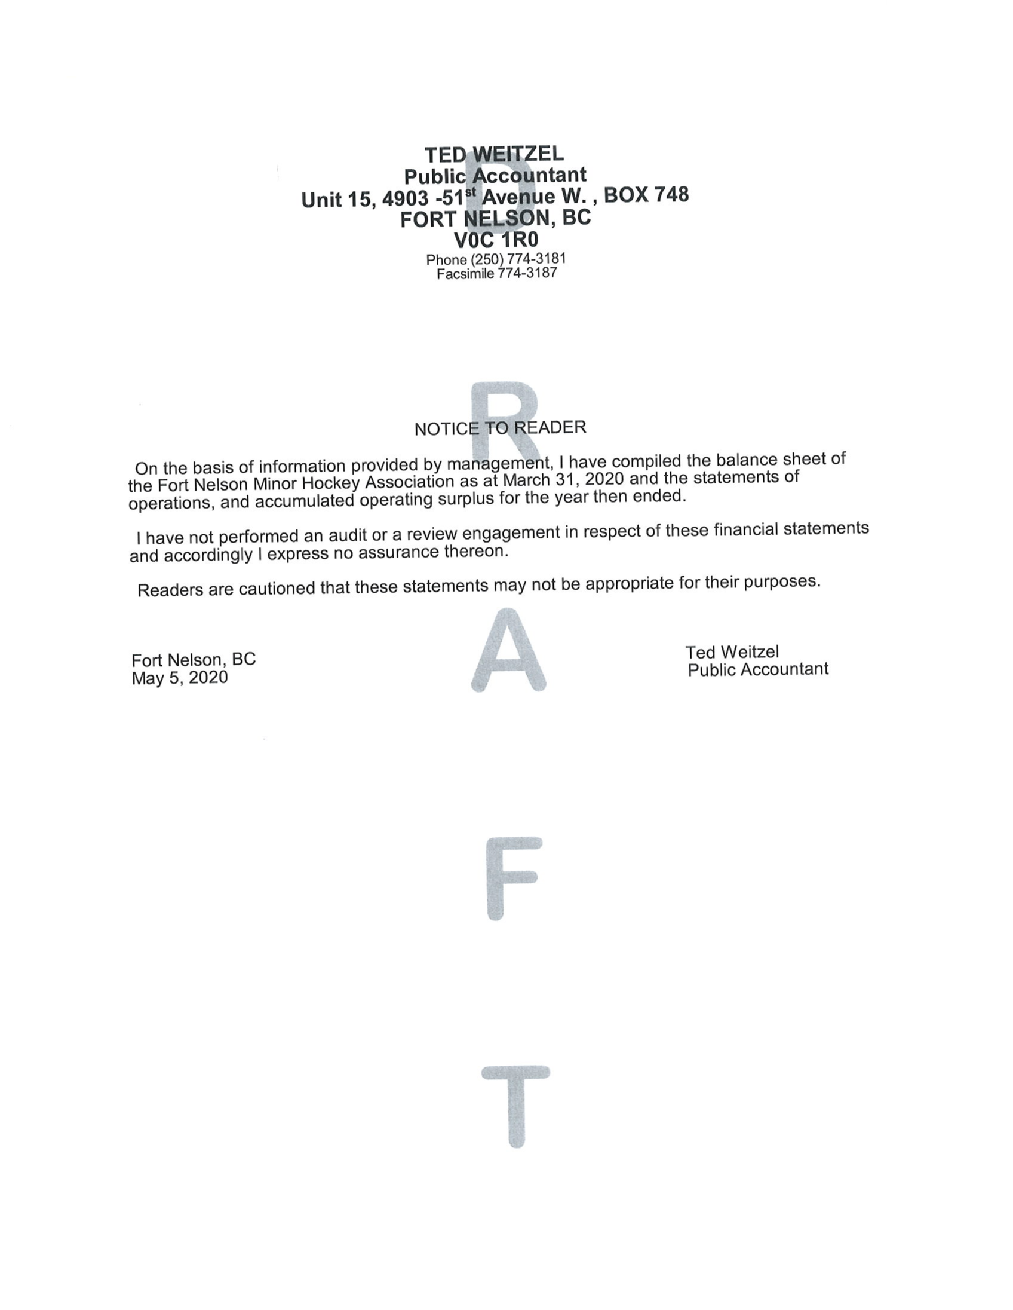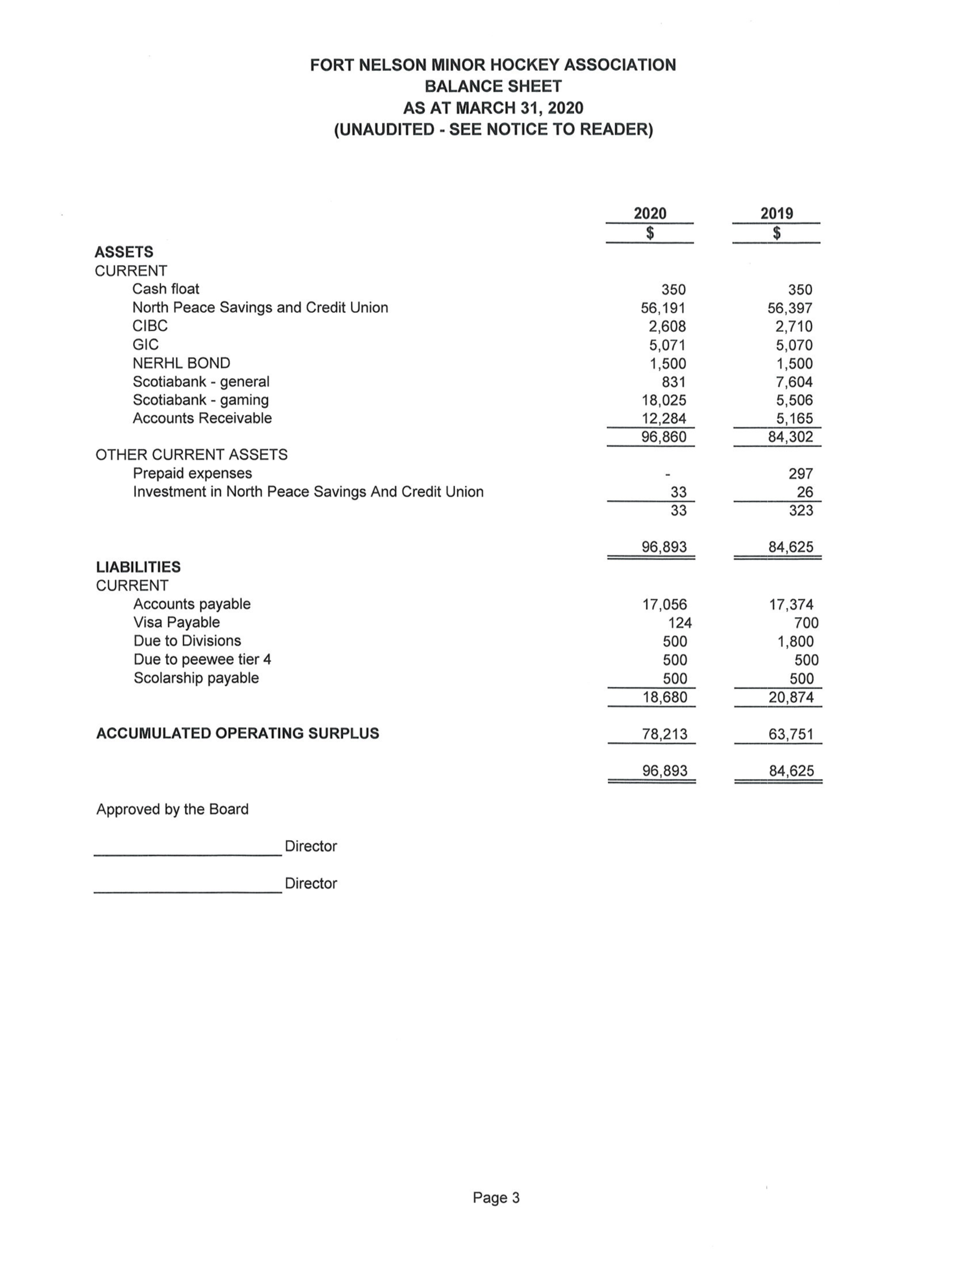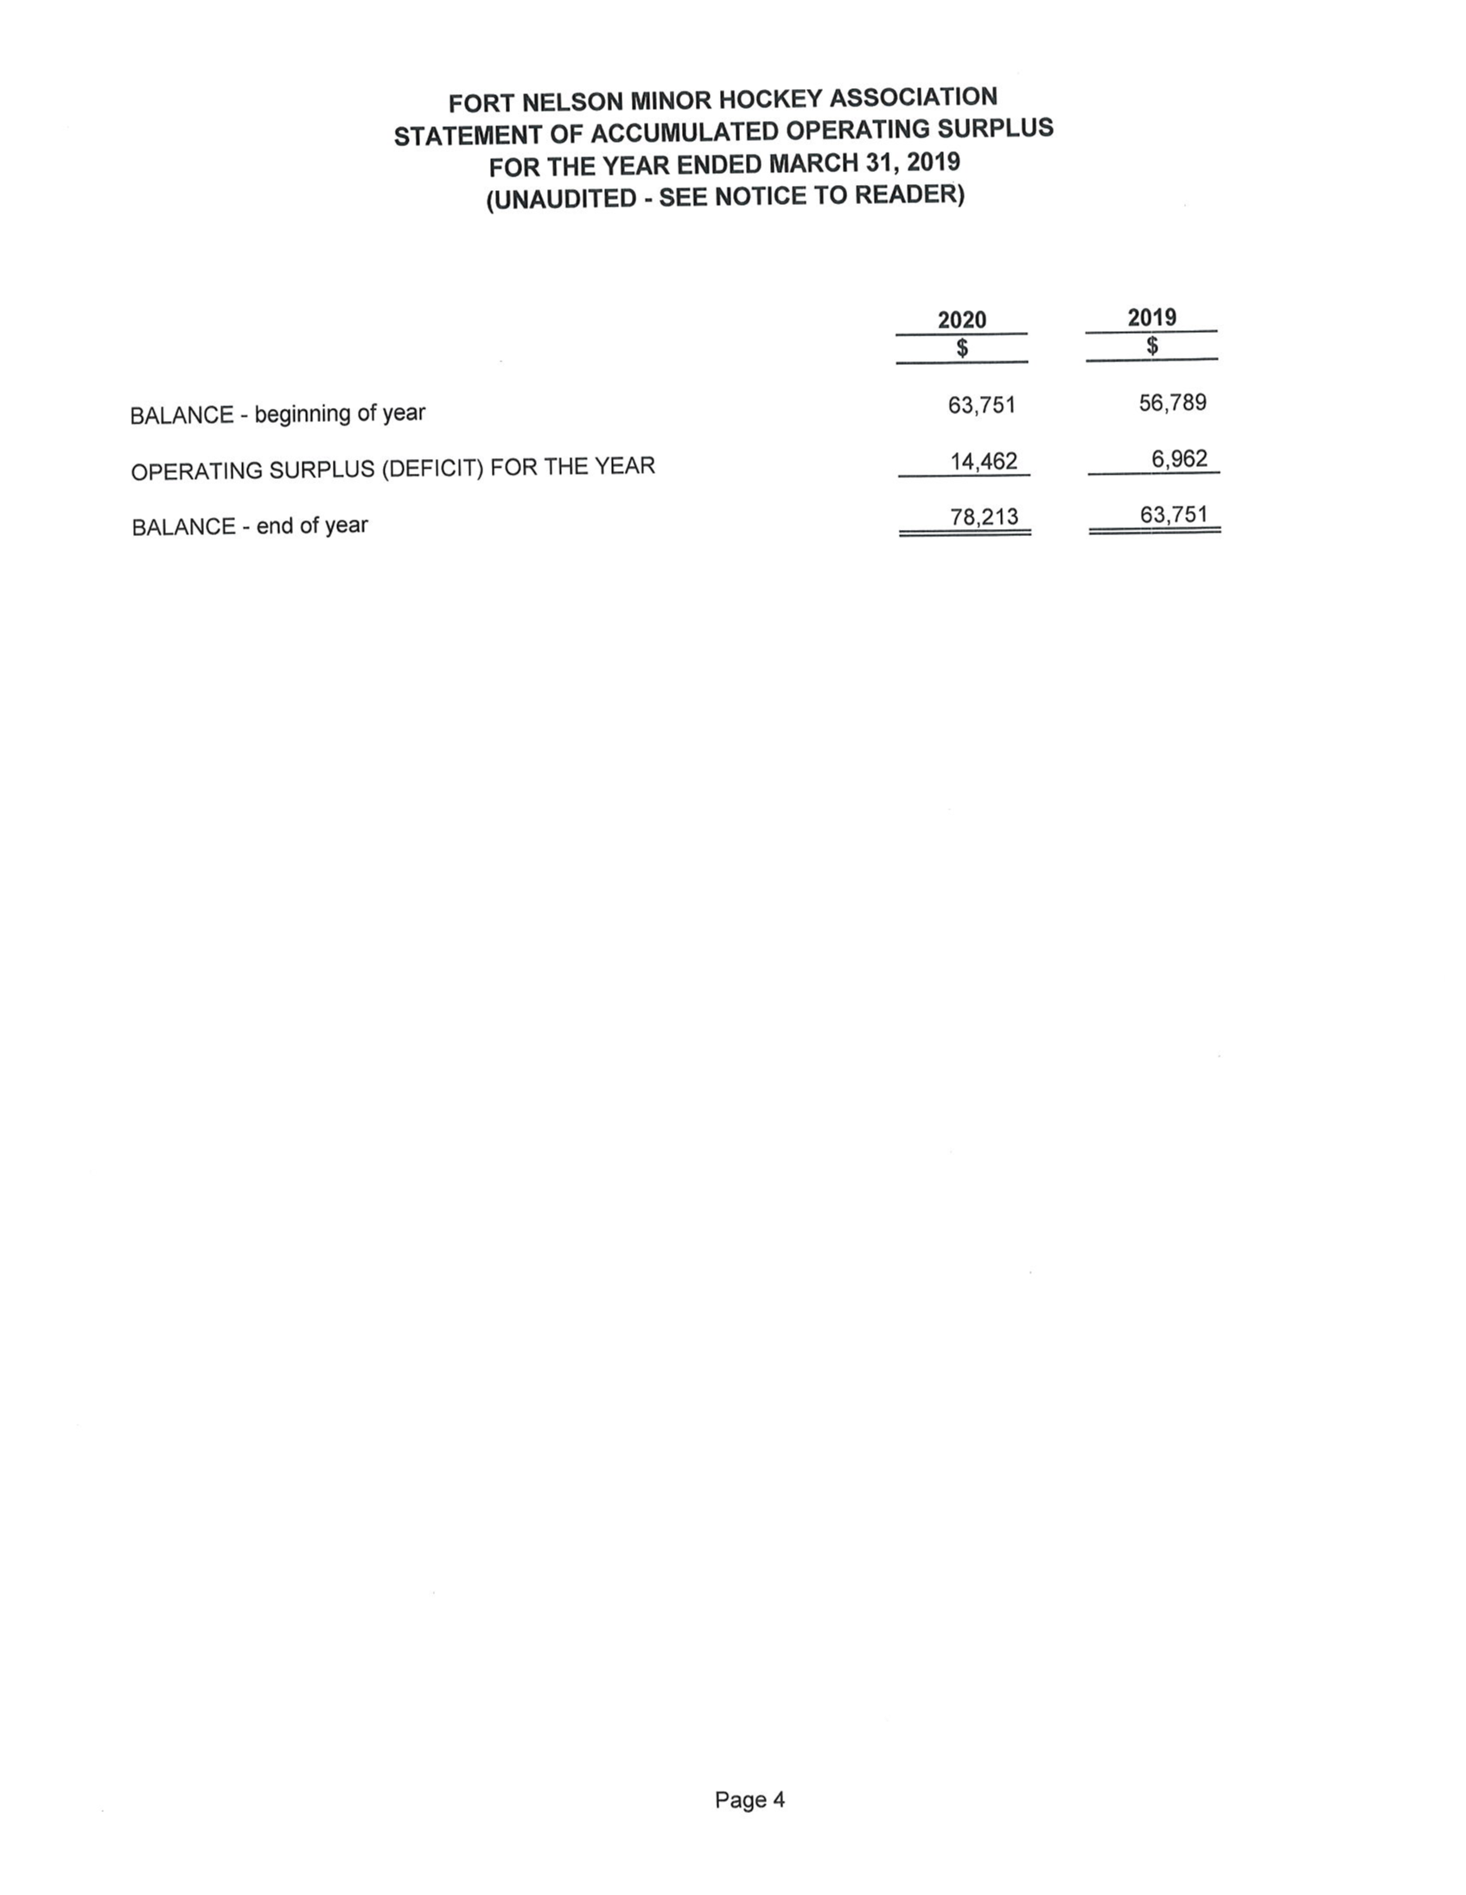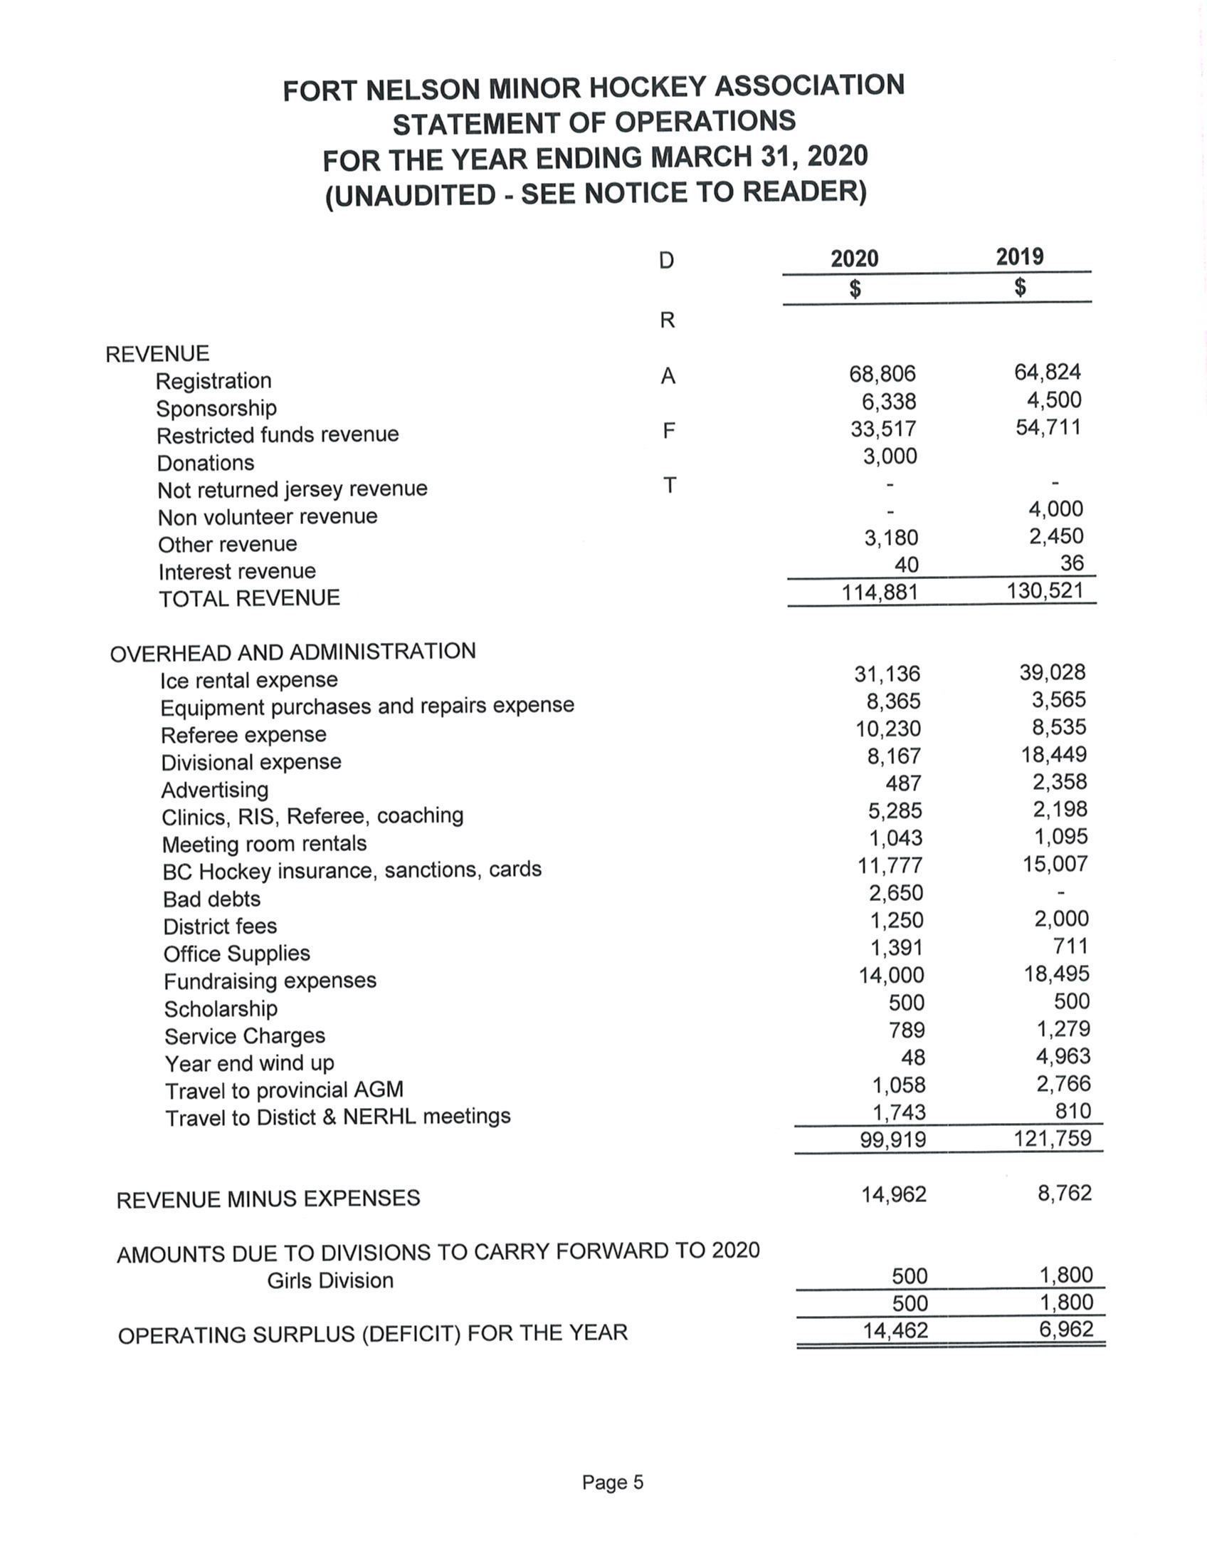

Motion to accept Financial Report: Shastine Fischer Second: Brenda Enax All in Favour

4. Reports of committees and or executive members

Girls - Shawna Wark :

Got refunded for the Kelowna trip. Haley Hannah has said she will take on the girls coaching position next year.

Midget - Brenda Enax:

Waiting for the items she ordered for her team with funds earned this year. She will find a way to present it to them.

Bantam – Shastine Fischer :

Nothing to add at this time.

Pee Wee - Weylin Ashdown :

Nothing to add at this time.

Atoms - Heather Eling :

Most of the team jackets have been handed to the players, still a few waiting for arrangements to be made. Ryan Carter mentioned the disappointment of the Atoms Travel Team which had their major tournament in Edmonton cancelled due to Covid-19.

Novice - Nicole Ashdown :

Nothing to add at this time.

Pre-novice – Jenn Thomas :

Nothing to add at this time.

Fundraiser - Janelle Badine :

Nothing to add at this time.

Ice Coordinator - Lisa Rowley :

Still waiting on word for ice users meeting. Ryan confirmed we had asked for these meetings to be moved until July so that would be the earliest she would likely hear. It may be later due to Covid-19.

Registrar - Heather Robinson :

Nothing to add at this time.

Head Referee - Kai Potter : (absent)

Vice President - Shastine Fischer:

Nothing to add at this time.

Equipment Manager - Linda Brenton : (absent)

Gaming Coordinator - Holly Leroux : (absent)

Publicity - Jason Kay :

Nothing to add at this time.

Risk Manager - Sonny Olkh :

Nothing to add at this time.

Head Coach - Ryan Kerr : (absent)

Treasurer – Katina Vatcher :

Needs some cheques signed. Has begun work on transition for passwords etc. Will begin the handover to the new treasurer soon.

President - Ryan Carter :

Has been following the BC Hockey and Hockey Canada updates regarding potential changes for Minor Hockey. New protocols will be necessary due to Covid-19. Things will be different but we do not know at this point how things will look, we may not even have NERHL so could be a very different season.. We can’t plan out in details but we will move forward as normal until we know more and make changes as necessary when recommendations and requirements are unveiled.

5. Unfinished Business

No unfinished business carrying over from 2019 AGM.

6. Election of New Officers

Slightly different protocol than in the past as explained by Ryan Carter at the beginning of the meeting. There is no voting at this time, all positions announced by acclimation due to single nominations.

- President: Ryan Carter elected by acclimation
- Vice President: Shastine Fischer elected by acclimation
- Treasurer: Shawna Wark elected by acclimation
- Secretary: Heather Eling elected by acclimation
- Head Coach: Weylin Ashdown elected by acclimation
- Head Referee: Kai Potter elected by acclimation
- Risk Manager: Sonny Olkh elected by acclimation
- Registrar: Heather Robinson elected by acclimation
- Publicity: Jason Kay elected by acclimation
- Ice Coordinator: Lisa Rowley elected by acclimation
- Gaming Coordinator: Holly Leroux elected by acclimation
- Fundraiser: VACANT
- Equipment Manager: Sean O’Shaughnessy elected by acclimation
Division Coordinators
- PreNovice VACANT
- Novice Nicole Ashdown elected by acclimation
- Atoms VACANT
- PeeWee VACANT
- Bantams VACANT
- Midget Brenda Enax elected by acclimation
- Girls VACANT

7. New Business

- PRDMHA AGM – No word on when this will be but will likely be a ZOOM meeting.
- BC Hockey AGM – Also no word on when this will be but will also likely be a ZOOM meeting.
Next Executive meeting will be Wednesday June 3rd at 7pm via ZOOM. Invitations will be sent before the meeting.

Priorities for the new executive:
- Rebranding – new logo design needs to be decided and we will need to order all new jerseys as we did not collect them at the end of last season.
- Registration changes – Looking into a new registration platform/system.
- New division names – Hockey Canada has renamed the divisions by age group eg. Under-7s; Under-9’s etc.

8. Adjournment

Motion to adjourn meeting: Katina Vatcher Second: Jenn Thomas All in Favour

Meeting Adjourned 7:30PM

